Ooad assignment 2025

NAME: Mogomotsi Vunika
ID:Cse24-080

Requirements Elicitation

  - Functional Requirements

InterviewRecord:
Interviewer: Student
Interviewee: Lecturer
Date: September/18/2025
Purpose: To identify functional requirements for the new Banking System

Key Functional Requirements Identified:

- Customer Management
  - The system must support creation of both individual and company accounts
  - Individual customers require personal identification details (ID number, date of birth)
  - Companies require business registration details and contact person information
  - Each customer must have unique login details
- Account Management
  - Support three account types: Savings, Investment, and Cheque accounts
  - Savings accounts: No withdrawals allowed, interest-bearing
  - Investment accounts: Minimum $500 opening balance, allows withdrawals, higher interest
  - Cheque accounts: Requires employer information, allows transactions
  - Customers can open multiple accounts of different types
- Transaction Processing
  - Customers can deposit funds to any of their accounts
  - Withdrawals only from Investment and Cheque accounts
  - Customers should be able to view complete transaction history
- Interest Calculation
  - Different interest rates for individual (2.5%) and corporate (7.5%) customers
  - Interest applied monthly to Savings and Investment accounts
  - System must automatically calculate and apply interest based on account balances
- Authentication & Authorization
  - Separate login interfaces for customers and bank tellers
  - Only bank tellers can create customer accounts
  - Customers can only access their own accounts and transactions
  - Secure password protection for all accounts
- Data Persistence
  - All customer, account, and transaction data must persist between sessions
  - Transaction history must be maintained permanently
- Balance Inquiry
  - Customers can check current balances for all their accounts
  - Real-time balance updates after each transaction

InterviewAppendix:
During the interview, the Lecturer emphasized the need for a reliable system that could handle different customer types with different requirements.The system must prevent unauthorized withdrawals from savings accounts while allowing flexibility for investment and cheque accounts. Security was highlighted as a critical concern, with requirements for proper authentication and data protection.The system should allow only the management to add customers and so provide different interfaces for both.

  - Non-Functional Requirements

- Security
  - Secure authentication mechanism with password protection
  - Authorization checks to prevent unauthorized access to accounts
  - Session management to protect against unauthorized use
  - Secure data storage with protection against tampering
- Usability
  - clear menu navigation
  - Simple account management processes
  - Clear presentation of financial information
  - Responsive design that provides immediate feedback
- Reliability
  - System must handle invalid inputs gracefully without crashing
  - Data consistency maintained across all operations
  - System availability during banking hours
- Performance
  - Responsive user interface with minimal processing delay
  - Efficient data storage and retrieval mechanisms
- Maintainability
  - Allow for future enhancements
  - Easy to update interest rates and banking rules
  - Accommodate growing customer base
- Compatibility
  - Platform independence (able to run on different operating systems)
- Data Integrity
  - Accurate calculation and application of interest
  - Consistent transaction recording and balance updates

2.Structural UML Modelling

- System Use Case Diagram

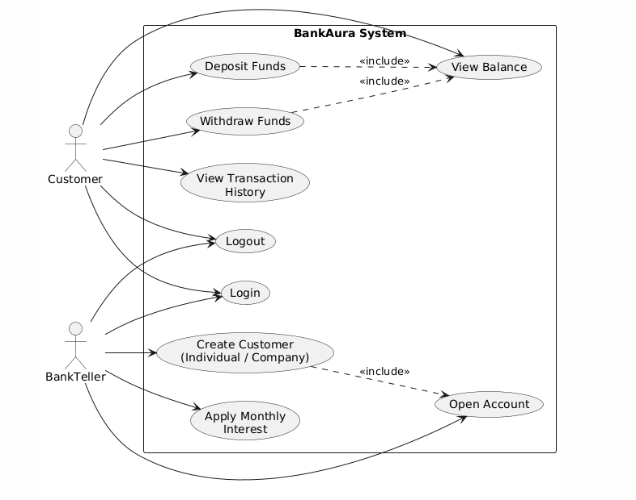

- Class diagram
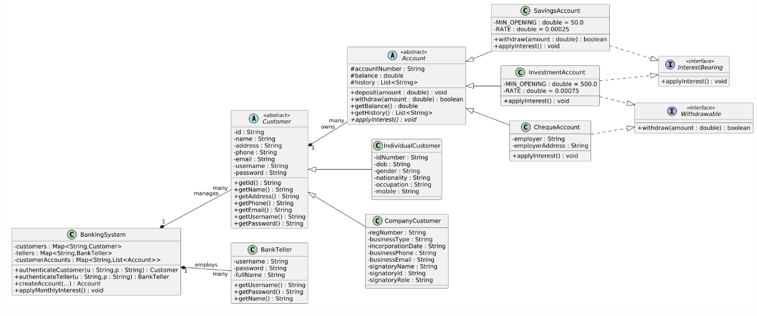

- Sequence Diagrams

- login

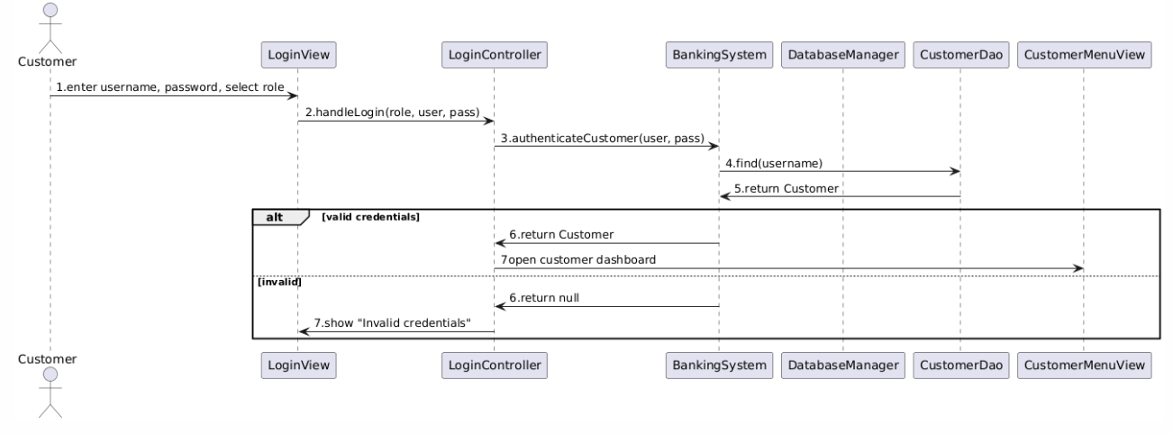
- deposit
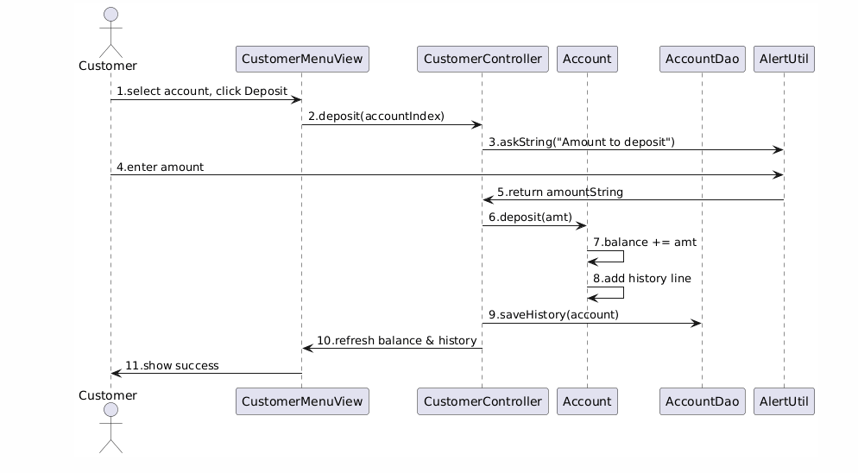

- State Diagram

